Alistana Fitness & Nutritional Tracker (AFNT)

Application

Ali Suhail

21072712

UXCFXK-30-3

Digital Systems Project



# Abstract

# Acknowledgements

Contents

Abstract 2

Acknowledgements 3

Table of Figures 5

1. Introduction 6

2. Literature Review 7

2.1. Technological Advancements and Human Lifestyle 7

2.2. Benefits of an Active Lifestyle 8

2.3. Evolution and Rise of Health and Fitness Tracking 9

2.4. Fitness and Health Tracker Varieties 10

2.4.1. Common Categories of Fitness and Health Trackers 11

2.4.2. Evolving Trends in Fitness and Health Tracking 12

2.5. Effectiveness of Fitness Trackers 12

2.6. Understanding the Risks Associated with Fitness Trackers 13

2.7. Ethical Considerations 14

2.8. Development Research Plan 14

2.8.1. Success Criteria 16

2.8.2. Technical Knowledge 16

2.8.3. AFNT Evaluation Criteria 18

2.8.4. Requirements Gathering 20

3. Requirements 24

4. Methodology 25

5. Design 26

6. Implementation 27

7. Project Evaluation 28

8. Further Work and Conclusions 29

Glossary 30

Table of Abbreviations 31

9. References / Bibliography 32

Appendix A: First Appendix 33

# Table of Figures

Figure 1: Life Expectancy 10,000 BC - Today (Cato Institute) 7

Figure 2: Fitness app annual users 2015-2021 8

Figure 3: Fitness in-app purchase revenue by app 2021 ($mm) 10

Figure 4: Fitness App Types. 11

Figure 6: Variables measured over a 36-week study for Type 2 Diabetic patient using Fitbit (Thomas William Miller, 2017). 12

Figure 7: Samsung Information Sharing Policy. 14

Figure 8: AFNT Fitness Tracker Initial Questions. 15

Figure 9: What I Need to Find Out. 16

Figure 10: Arduino Watch Components. 17

Figure 11: Assembly of All Arduino Watch Modules 18

Figure 12: First Version of Arduino Watch Interface (24/01/2024). 18

Figure 13: AFNT and Arduino Watch Evaluation Table. 19

Figure 14: Samsung Galaxy Watch (2018). 20

Figure 15: Fitbit Flex 2 (2016). 20

Figure 16: My Personal Workout Tracking Method Using Excel Spreadsheet. 22

Figure 17: My Personal Workout Data Using Excel – 2023 23

Figure 18: My Workout Progress Evaluation – 2023 23

Figure 19: AFNT Project Phases 24

# Introduction

**Incomplete**

Currently, one of the biggest challenges the world is facing is a global obesity pandemic, which has become an especially acute problem in the developed world. According to The Guardian, around 38% of the global population, approximately 2.4 billion people, are currently categorized as overweight or obese. Without the widespread adoption of measures such as taxing and limiting the promotion of unhealthy foods, this trend is expected to persist. By 2035, it is predicted that the percentage of clinically obese individuals will rise from one in seven to one in four, with more than half of the total population being obese or overweight (Campbell, 2023). Having said that, the rapid increase of obesity rates will lead to higher chances of diseases and illnesses, which will have a greater burden on the healthcare sector and the overall productivity of the economy (‘Obesity Consequences’, 2012).

The key contributors of obesity and overweightness can be summarized to the consumption of high-calorie, fatty foods that are easily accessible, combined with a lack of physical activity (Wright and Aronne, 2012). This research will focus on ways to tackle this complex problem.

The main goal of this research is to develop the Alistana Fitness & Nutrition Tracker (AFNT) program, a free and inclusive application promoting health-conscious behaviour. AFNT aims to raise awareness about the benefits of regular exercise and a balanced diet, reducing healthcare burdens and lowering disease risks, including obesity. The application empowers users to track workouts, nutrition, and body progress securely, ensuring compatibility with mobile and desktop devices.

Maintaining good health and fitness is crucial as it benefits not just physical well-being but mental health as well. Engaging in regular exercise and fitness activities can elevate self-confidence, enhance attractiveness, and foster a health-conscious lifestyle, encompassing balanced nutrition and proper sleep. This holistic approach to well-being not only boosts productivity but also alleviates the financial burden on individuals and the healthcare system at large. By embodying a healthy lifestyle, individuals can inspire others to pursue their fitness goals, thereby fostering a community that values and prioritizes health and well-being.

The outcome:

The report consists of 8 chapters. Chapter 2 provides a critical review of the AFNT Project. Chapter 3 delves into detailed requirements and objectives for the Database Management System (DBMS), AFNT Application, AM Website, and Arduino Watch. Chapter 4 focuses on the Agile methodology used in AFNT development, while Chapter 5 explores AFNT's design architecture. Chapter 6 covers the project's implementation, with Chapter 7 dedicated to its evaluation. Finally, Chapter 8 concludes the report and outlines further work.

# Literature Review

## Technological Advancements and Human Lifestyle

Throughout human history, technological advancements have played a pivotal role in making daily activities more efficient and less labour-intensive. From the invention of tools by Homo habilis to the industrial revolution, innovations like the wheel, carts, and various modes of transportation have transformed the way people live and work (Woessner *et al.*, 2021). The Industrial Revolution further enhanced productivity and ushered in an era of electronic and telecommunications revolution, introducing household appliances that reduced manual labour. Simultaneously, advancements in medicine, spanning over two millennia, have significantly contributed to improved healthcare and increased life expectancy. The twentieth century witnessed breakthroughs such as vaccines, early disease diagnosis, and treatment innovations, resulting in a substantial rise in life expectancy to around 80 years.

Figure : Life Expectancy 10,000 BC - Today (Cato Institute)

However, alongside these benefits, technological proliferation has resulted in a significant decline in incidental physical activity. Everyday activities like active transport and manual labour have been replaced or reduced by technological solutions. The advent of the internet, especially accessible through mobile devices, has further contributed to increased sedentary behaviour, with established associations between internet usage during leisure time and obesity. The overall reduction in physical activity, coupled with a surge in sedentary behaviours, has become a significant factor in the obesity epidemic. Despite technology's positive impact on healthcare and life expectancy, addressing the challenges posed by reduced physical activity remains crucial for promoting overall well-being (Woessner et al., 2021).

Another significant contributor to the rapid increase in obesity rates is the heightened caloric intake, particularly from sweetened beverages, as emphasized by Caballero (2007). These dietary changes, marked by increased consumption of energy-dense foods and a shift away from healthier options, play a substantial role in the current health crisis. The availability of low-cost, easily accessible, and energy-dense food items, combined with changes in dietary patterns, emerges as a prominent factor in the rising rates of obesity. Addressing dietary choices and promoting healthier eating habits are critical components of strategies aimed at combating the obesity epidemic (Caballero, 2007).

Fortunately, technology's ascent has spawned innovative tools for achieving a healthier lifestyle, including mobile phones, smartwatches, and a variety of health and fitness technologies. This market encompasses meditation and workout apps, wearables, connected home gym equipment, Wi-Fi-enabled bathroom scales, and more, offering solutions for weight loss, stress reduction, improved sleep, enhanced immunity, elevated mood, and better nutrition (Moscaritolo, 2024). Additionally, the COVID-19 pandemic accelerated the adoption of health and fitness apps, by gyms closing due to the pandemic, this forced individuals to maintain their well-being from the comfort of their homes. The iOS app market, as analysed by Pankush Kalgotra, Raja, and Sharda (2022), exceeded growth expectations by 29.9%, highlighting the increasing demand for health and fitness-related apps during and after the pandemic.

Figure : Fitness app annual users 2015-2021

## Benefits of an Active Lifestyle

Engaging in regular exercise not only contributes to improved mental well-being, reducing feelings of anxiety and depression, as highlighted by the Mental Health Foundation (2015), but it also plays a pivotal role in weight management by aiding in the burning of excess calories and enhancing metabolism, according to Mayo Clinic (2023). Additionally, exercise has been shown to enhance brain function, safeguarding memory, and thinking skills, thereby promoting overall cognitive health (Godman, 2014). Beyond mental and cognitive benefits, regular physical activity significantly enhances sleep quality, facilitating quicker sleep onset and deeper sleep experiences ('How Can Exercise Affect Sleep? | Sleep Foundation', 2013). Moreover, exercise positively influences the immune system by promoting optimal circulation and facilitating the efficient movement of immune system cells and substances throughout the body ('How to boost your immune system - Harvard Health', 2014). This multifaceted impact underscores the holistic benefits of incorporating regular exercise into one's lifestyle.

## Evolution and Rise of Health and Fitness Tracking

In the present era, digital and wearable health and fitness technologies seamlessly integrate into our daily lives, with smartphones acting as versatile fitness tracking devices. What sets today's technologies apart is their unparalleled personalization. Unlike the mass-oriented approaches of early 1900s entrepreneurs, modern wearables and health apps delve deep into personal tracking, monitoring everything from dietary habits and sleep patterns to movement frequency and body composition (Millington, 2018).

One of the biggest reasons for the high popularity of health and fitness tracking apps can be attributed to the preference for convenience and flexibility, diverging from traditional gym attendance. A study by Better UK (2020) identified reasons such as time constraints, low confidence, crowded gym environments, and familial obligations as factors influencing people to choose fitness apps over gym visits. Despite gyms offering various tools and fitness trainers, the associated expenses, including costly gym membership fees and personal trainers, make these options financially challenging for some (thefitnessgrp, 2023). Consequently, the cost-effectiveness and accessibility of fitness apps, coupled with the opportunity to adhere to expert guidelines, have led to a growing inclination towards utilizing virtual trainers for fitness training at home, accommodating diverse lifestyles and preferences.

Portability has been another transformative factor in the rapid popularity of fitness-tracking apps. In the late 1800s, Charles Wesley Emerson lamented the immobility of exercise equipment like dumbbells. Even in the late 20th century, health and fitness practices were confined mostly to gyms and homes (Millington, 2018). The breakthrough came with smartwatches like Pebble and Apple Watch, offering not just time-telling but also fitness tracking, app integration, and mobile payment capabilities. These multifunctional wearables evolved from niche fitness gadgets to mainstream devices, capturing consumer imagination. In 2009, James Park and Eric Friedman initiated a revolution with Fitbit, launching the Fitbit Classic—a wearable measuring steps, distance, and calories burned. By gamifying the impactful metric of daily steps, Fitbit mainstreamed the concept that anyone can measure health-affecting metrics, and technology can assist in monitoring. Over fourteen years, health and fitness apps burgeoned into a market worth over $8 billion in 2023, attracting nearly 400 million users in 2021 (‘Fitness App Revenue and Usage Statistics’, 2024).

Figure : Fitness in-app purchase revenue by app 2021 ($mm)

Fitbit's success influenced major technology players like Apple and Google to enter the fitness app realm, propelled by the widespread adoption of iPhones and the App Store. The Apple Watch, renowned for gathering intricate biometric data, marked a transformative phase in health tracking with apps and wearables monitoring diverse health metrics, including heart rate, sleep patterns, and stress levels. Apple has extended its tracking capabilities beyond fitness to healthcare, unveiling products like the Apple Watch Series 4 and subsequent iterations. These devices not only track irregular heartbeats but also measure blood oxygen levels, have fall detection, and facilitate automatic emergency calls (‘Healthcare - Apple Watch’, 2017). These technologies demonstrate Apple's commitment to advancing technology for comprehensive healthcare solutions.

Fitness trackers, once simple step counters, have evolved into sophisticated health companions. They now feature comprehensive insights into various aspects of physical well-being, from heart rate monitoring and sleep tracking to GPS navigation. Motivating users through goal setting and progress tracking, fitness trackers incorporate gamification elements, adding fun and competition to the fitness journey. Beyond functionality, these trackers have become fashion-forward accessories, seamlessly integrating with everyday attire for constant monitoring of vital health metrics (Waghchoure, 2023).

## Fitness and Health Tracker Varieties

### Common Categories of Fitness and Health Trackers

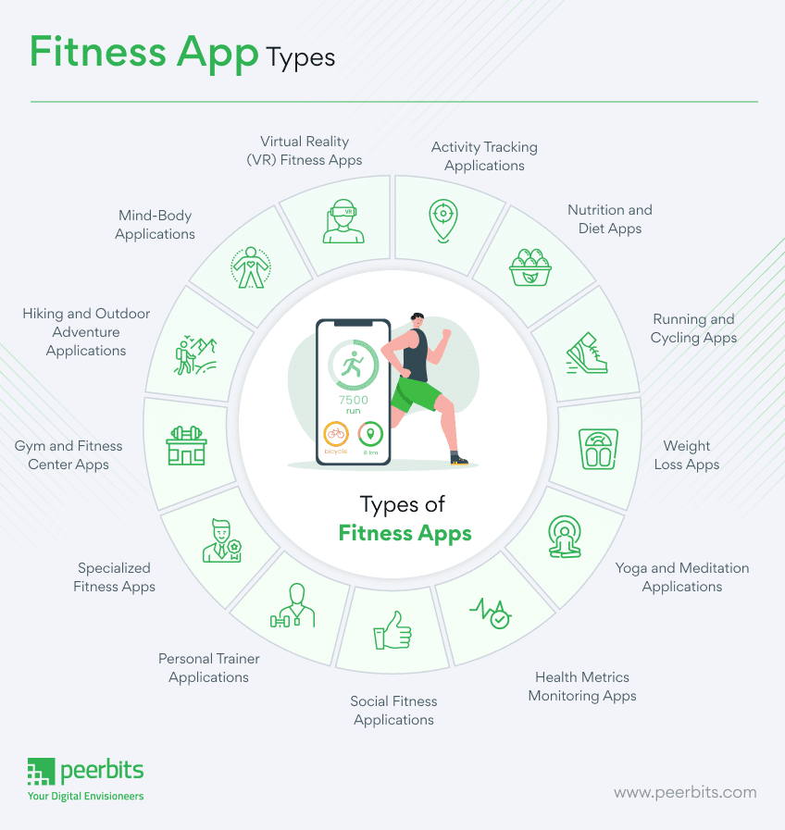

Figure : Fitness App Types.

**Activity Tracking: These apps utilize sensors in smartphones or wearable devices to monitor physical activities such as steps taken, distance covered, and calories burned. They provide users with real-time feedback on their activity levels and are exemplified by popular apps like Samsung Health** (‘Samsung Health’, 2023)**.**

**Workout and Exercise: Designed to cater to various fitness levels and goals, workout and exercise apps offer a wide range of routines and fitness plans. Users can choose from strength training, cardio workouts, yoga sessions, and more, depending on their preferences and objectives.**

**Nutrition and Diet: Nutrition and diet apps play a crucial role in helping users maintain a balanced diet and healthy eating habits. They enable users to track their calorie intake, plan meals, and receive nutritional guidance based on their dietary preferences and goals. Well-known examples include MyFitnessPal** (‘MyFitnessPal’, 2024) **and Lose It!** (‘Lose It!’, 2022).

**Running and Cycling: These apps are tailored specifically for runners and cyclists, offering features such as GPS tracking, route planning, and pace monitoring. Apps like Strava are popular among outdoor enthusiasts for their ability to track and analyse performance metrics during runs and rides** (‘Strava’, 2024).

**Health Metrics Monitoring: These apps integrate seamlessly with wearable devices like Fitbit** (‘Fitbit, 2024) **or Garmin Connect** (‘Garmin’, 2019) **to monitor various health metrics such as heart rate, blood pressure, and sleep patterns. They provide users with valuable insights into their overall health trends and help them make informed decisions about their well-being.**

**These categories encompass a diverse array of fitness app types that cater to different user needs and preferences. While the mentioned categories cover a broad spectrum of fitness and health-related activities, there are also specialized apps (**Figure 4**) available for specific activities or health goals, highlighting the ever-evolving nature of digital health and fitness technology.**

### Evolving Trends in Fitness and Health Tracking

**Wearable Technology: Leading fitness trackers and smartwatches, such as Fitbit and Apple Watch, utilize advanced sensors to monitor a range of health metrics, including heart rate, sleep patterns, and physical activity. These devices, equipped with GPS technology, can track outdoor activities, and measure additional factors like skin temperature and blood oxygen levels (‘Fitbit’, 2023).**

**Machine Learning and AI: My Fitness Pal employs a mobile app featuring Machine Learning (ML) algorithms for personalized workout and nutrition recommendations. Analysing users' workout history, biometric data, and relevant information allows the application to adapt and offer more effective, tailored suggestions (‘MyFitnessPal’, 2023).**

**Natural Language Processing (NLP): Virtual assistants like Apple’s Siri and Google Assistant utilize NLP technology to interpret and respond to voice commands, facilitating hands-free operation of fitness apps during workouts.**

**Computer Vision: In workout apps, Computer Vision technology ensures users maintain proper exercise form. By analysing video data, computer vision algorithms provide real-time feedback on exercise techniques, promoting correct form.**

## Effectiveness of Fitness Trackers

Wearable activity trackers have emerged as cost-effective tools to combat physical inactivity. A comprehensive review of 39 systematic reviews and meta-analyses, spanning diverse populations, demonstrated the positive impact of activity trackers on physical activity, body composition, and fitness, resulting in approximately 1800 extra steps per day, 40 additional minutes of walking, and about 1 kg reduction in bodyweight (Ferguson et al., 2022).

In a case study, the effectiveness of a wearable fitness tracker, specifically a Fitbit, was explored in a 36-week intervention program for an overweight, type 2 diabetic, geriatric subject. The integrated use of the Fitbit reported qualitative improvements in active minutes, steps taken, miles walked, calorie intake, sleep duration, and liquid consumption. The subject significantly increased daily walking distance from less than one mile to over 4.6 miles, nearing the recommended 5 miles per day goal. The technology facilitated continuous monitoring by the healthcare team, showcasing positive changes in exercise dedication and overall well-being (Thomas William Miller, 2017).

Figure : Variables measured over a 36-week study for Type 2 Diabetic patient using Fitbit (Thomas William Miller, 2017).

Moreover, another case study that involves a virtual fitness trainer app, assessed through the Situational Motivational Scale (SIMS) with 54 students, demonstrated effectiveness in motivating and engaging users in fitness activities. The app's virtual trainers positively influenced students' motivation, making the activities enjoyable and beneficial for their fitness levels. Respondents found the activities interesting, fun, and essential, highlighting the app's potential to enhance engagement and motivation in fitness-related endeavours (Mokmin and Nurullizam Jamiat, 2020).

In summary, the evidence suggests that wearable fitness trackers, exemplified by Fitbit and virtual trainer apps, play a crucial role in enhancing physical activity, motivating users, and positively impacting overall health and well-being.

## Understanding the Risks Associated with Fitness Trackers

Fitness tracker apps, with their extensive data collection and sharing capabilities, introduce significant privacy and security risks. A survey of 11,000 mobile health apps, representing 5,000 developers, reveals that fitness and nutrition apps are particularly advanced in sharing user data via shared application programming interfaces (APIs) (‘Permissions on Android’, 2024). Sharing commonly occurs with data aggregators like Apple’s HealthKit, wearables, and directly between apps (Grundy, Held and Bero, 2017).

These apps serve diverse functions, accessing vast amounts of highly personal data, including location, text messages, and even camera or photo access (Olmstead, 2015). The inherent access to personal health information heightens privacy risks, with concerns about data being shared with third parties, including advertisers and data brokers (Grundy, Held and Bero, 2017)

The risks extend to information leaks, manipulation, and loss, as demonstrated by Li's privacy threat model (Li, 2015). User profiling across multiple sites can lead to aggregated user profiles, monetized for marketing, or even exploited for identity fraud (Grundy, Held and Bero, 2017).

Mobile health apps, including fitness trackers, routinely request numerous permissions, indicating a broad spectrum of data access. The most common permissions relate to internet access, with implications for data transmission and sharing (Grundy, Held and Bero, 2017).

Common fitness tracker apps like Samsung Health and Fitbit apps have encountered challenges in usability and data privacy, which have been documented in various sources. Usability issues, including complex interfaces and inconsistent user experiences, missing features have been noted by reviewers and users alike (‘Appconner’, 2021), along with inaccuracy in collected data in certain apps.

Fitbit's data collection policy outlines that personal data collected through its app, including fitness and health-related information, is used primarily for providing and improving its services, such as personalized recommendations and analytics (‘Fitbit Legal: Privacy Policy’, 2023). Similarly, Samsung Health's data collection policy states that user data, including fitness, nutrition, and biometric information, is utilized for enhancing user experience, research, and product development (‘Samsung Privacy’, 2024).

Figure : Samsung Information Sharing Policy.

## Ethical Considerations

In developing the AFNT app, ethical considerations play a crucial role in ensuring user trust and data security. The app must prioritize data privacy by complying with GDPR (‘Overview of UK GDPR’, 2016) and implementing secure storage and transmission measures. Intellectual property rights are respected, necessitating proper licensing for third-party content. Accessibility is a key focus, with the app designed to be inclusive and user-friendly for individuals with disabilities following WCAG guidelines (WCAG 2, 2018). Security measures are implemented for the DBMS and ensure encrypted data transfer from the Arduino watch. Hardware standards for the Arduino watch prioritize user safety and comfort. Battery optimization features guarantee prolonged operation, and both the website and app adhere to accessibility standards and offer a user-friendly interface. Compatibility across various mobile platforms and seamless integration with mapping APIs further enhance the app's ethical usability and accessibility.

## Development Research Plan

Embarking on the AFNT Fitness Tracker development necessitates a thorough grasp of technical nuances in each project component. A comprehensive understanding of challenges, tasks, and effective management approaches is crucial. Due to the extensive nature of the AFNT project, it will be initially segmented into five planning stages, as outlined in Figure 7.

Figure : AFNT Fitness Tracker Initial Questions.

### Success Criteria

Figure : What I Need to Find Out.

After extensive research and consultations with supervisors, I've restructured the planning phase for AFNT into five key categories, as illustrated in Figure 8. The success criteria revolve around the development of a fully functional AFNT application compatible with both mobile and desktop platforms. It should adeptly track workouts, meals, and body data, and visualize body progress through graphs (Aiming to amalgamate multiple types of fitness apps into one, as depicted in Figure 4). Additionally, the Arduino watch should seamlessly connect and synchronize data with the AFNT app via Bluetooth, providing real-time heart rate, blood oxygen levels, and step count data.

### Technical Knowledge

To facilitate diagramming, I've opted for Astah UML for its versatility, ease of use, and popularity in industry (‘Astah’, 2023). Excel will be utilized for sprint, testing, and planning logs due to its spreadsheet functionality, ease of use and the wide range of planning templates it offers (‘Excel | Microsoft 365’, 2016).

The database architecture will be divided into two components: The Central Database Server (CDB) and the Local Database (LDB). In the LDB, all user personal data will be stored locally, ensuring that it remains exclusively accessible to the user. The database will be created using SQLite, a highly popular and easy to use database modelling tool (‘SQLite’, 2024). This approach aligns with AFNT's commitment to maintaining the security and privacy of user data. Conversely, the CDB will house predefined workouts, meals, and user login credentials, facilitating secure login and access to AFNT's user data. CDB will be stored in a MySQL server due to its reliability, scalability, performance, security features, cross-platform compatibility, and strong community support, making it suitable for various applications (‘SQL Server’, 2022).

For the AM Website, Python Flask was chosen for its simplicity and widespread use in the industry (‘Flask Documentation (3.0.x)’, 2024). Extensive online resources are available to support effective implementation. In developing the AFNT application and Graphical User Interface (GUI), Python programming language and the Kivy GUI Framework was used as it offers flexibility and cross-platform support, making it an ideal choice. It's open-source and user-friendly (‘Kivy’, 2024).

Regarding the Arduino Fitness Watch, components from Tiny Circuits were selected for their compact design and ease of assembly, resembling modular electronic components akin to Lego blocks (‘TinyCircuits’, 2024). Tiny Circuits also boasts a supportive community and provides comprehensive documentation and basic examples to aid development (‘Tiny Circuit Projects’, 2022). All components were acquired at personal expense.

Figure : Arduino Watch Components.

Figure : Assembly of All Arduino Watch Modules

Figure : First Version of Arduino Watch Interface (24/01/2024).

### AFNT Evaluation Criteria

In this study, we will evaluate two widely used fitness tracker apps, Samsung Health, and Fitbit, based on their performance and features, as illustrated in Figure 9. AFNT stands out from Samsung Health (Paired with Samsung Galaxy Watch 1) and Fitbit app (Paired with Fitbit Flex 2) in several aspects:

Figure : AFNT and Arduino Watch Evaluation Table.

**Selection Rationale for Samsung Galaxy Watch and Fitbit Flex 2**: The Samsung Galaxy Watch and Fitbit Flex 2 were chosen for practical reasons, based on my prior experience with the Samsung Galaxy Watch, which enables thorough testing of both devices. Moreover, the Fitbit Flex 2 was selected due to its fitness-focused design akin to the Arduino Watch, distinguishing it from multipurpose/flagship smartwatches like the Apple Watch or higher-end Samsung models. Its core features centre on tracking activities such as steps, distance, calories, and sleep patterns, with limited smartwatch functionalities such as call and text notifications. Moreover, Including the original Galaxy Watch allows for a comparison of the Arduino watch's capabilities against a more advanced smartwatch in terms of both hardware and software, while cost considerations also influenced the selection process.

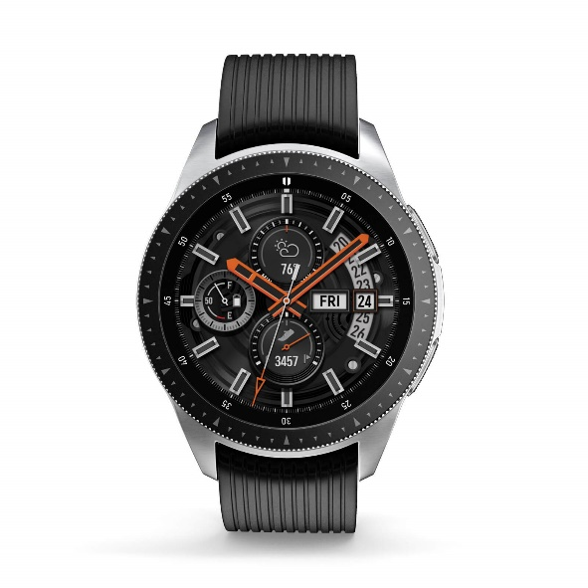

Figure : Samsung Galaxy Watch (2018).

Figure : Fitbit Flex 2 (2016).

**Privacy Measures**: AFNT emphasizes data privacy by storing user data locally on the device (LDB), ensuring that personal information is not utilized for marketing, advertisement, or analytical purposes as AFNT has no way to access this data. It also incorporates a feedback mechanism for users to share data securely, a feature less emphasized in Samsung Health and Fitbit apps.

**Cross-Platform Functionality**: AFNT is designed to function seamlessly across both mobile and desktop platforms, providing users with flexibility in accessing their fitness and health data. This versatility contrasts with the mobile-centric approach of Samsung Health and Fitbit apps.

**Customizable Workout Plans**: Unlike Samsung Health and Fitbit apps, AFNT allows users to tailor and customize their workout plans according to their specific fitness objectives and preferences, fostering greater user engagement and motivation.

**Enhanced User Control**: AFNT offers users extensive control over their fitness, health, and nutrition data. Users can modify nutritional details of food items, rate workouts, customize exercise aspects, allocate workouts and meals, and manage data synchronization across devices. This level of control enhances the user experience and personalization, surpassing what is currently offered by Samsung Health and Fitbit apps.

### Requirements Gathering

The app aims to provide a seamless user experience with features like customizable workout plans, nutritional tracking, and real-time health data from the Arduino watch. User-friendly interfaces, security measures, and cross-platform compatibility are fundamental requirements. These requirements were gathered in the following ways:

* Regularly consulting mentors like Martin Serpell and Eman Qaddoumi for industry insights and best practices in fitness app development.
* Analysing UI, features, and functionalities of popular fitness apps like Samsung Health and Fitbit to guide AFNT app design decisions.
* Tracking personal fitness progress at the gym and understanding user expectations firsthand (Figure 15, Figure 16 and Figure 17).
* Conducting comprehensive online research to stay abreast of emerging trends and user demands in fitness app development.

Figure : My Personal Workout Tracking Method Using Excel Spreadsheet.

Figure : My Personal Workout Data Using Excel – 2023

Figure : My Workout Progress Evaluation – 2023

# Requirements

**Incomplete**

Figure : AFNT Project Phases

# Methodology

# Design

# Implementation

# Project Evaluation

# Further Work and Conclusions

# Glossary

# Table of Abbreviations

# References / Bibliography

‌

# Appendix A: First Appendix